**Output Screenshots:**

1.Home-Page:

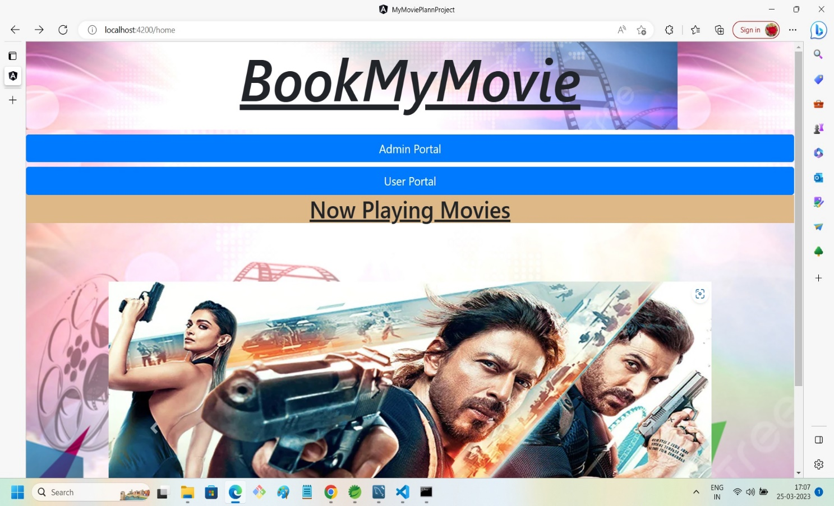

2.Admin Front Page:

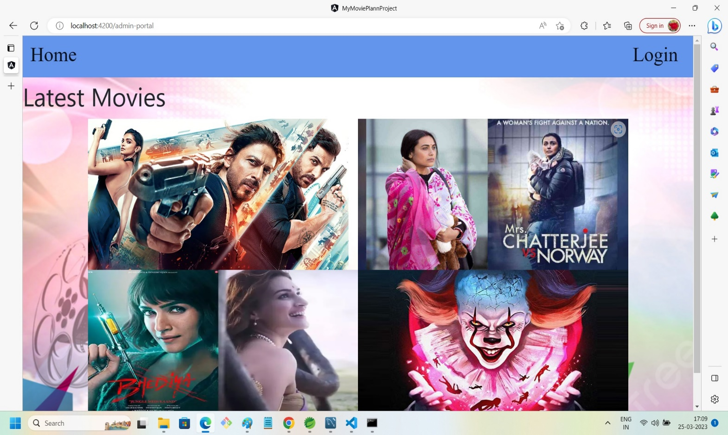

3.Admin Login-Section:

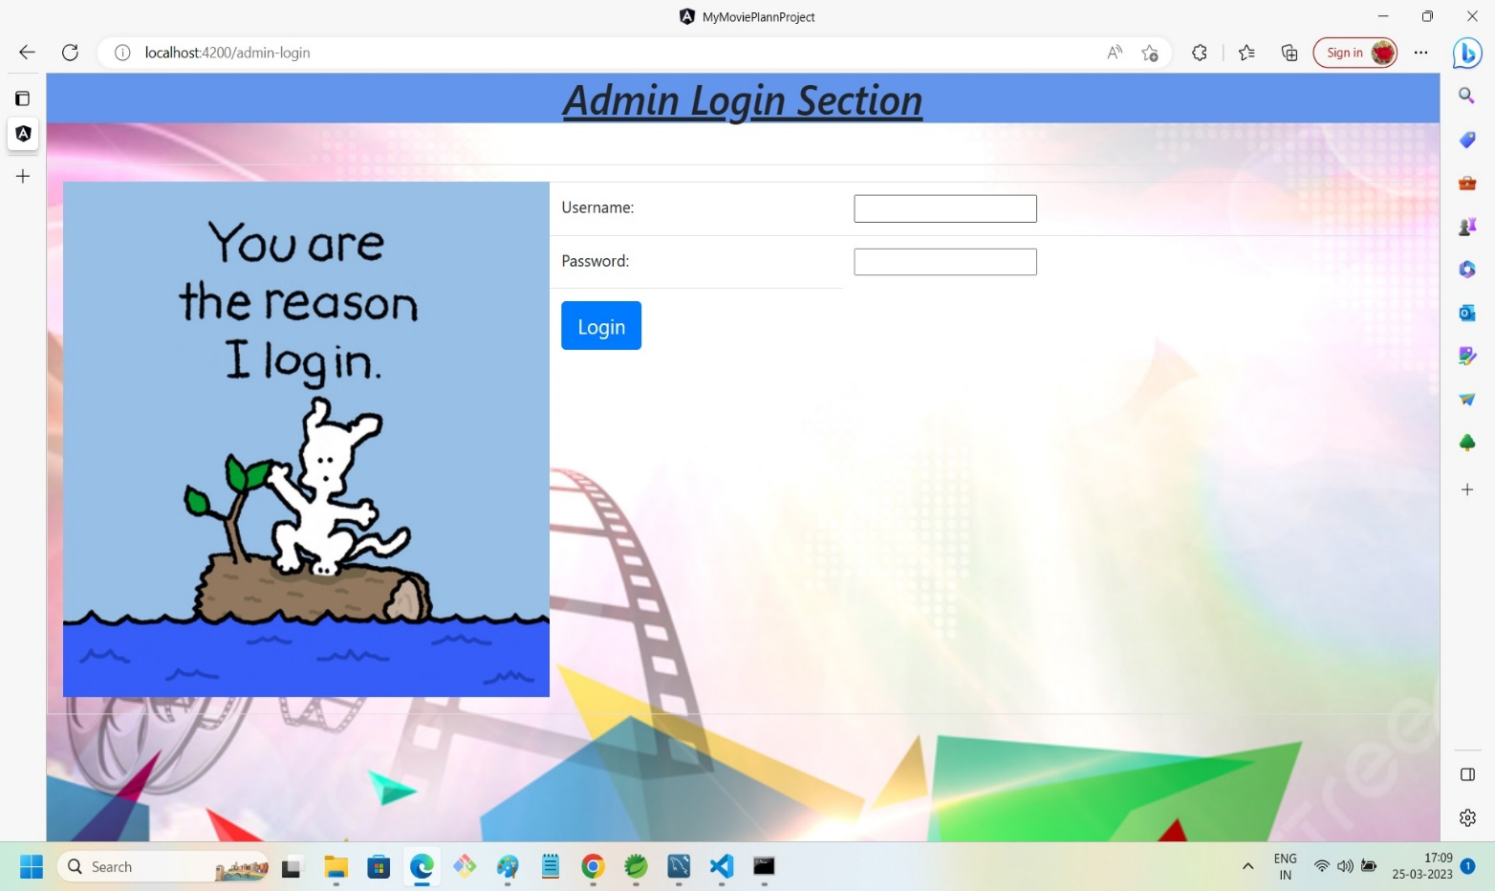

4.Admin Wrong Credentials Message:

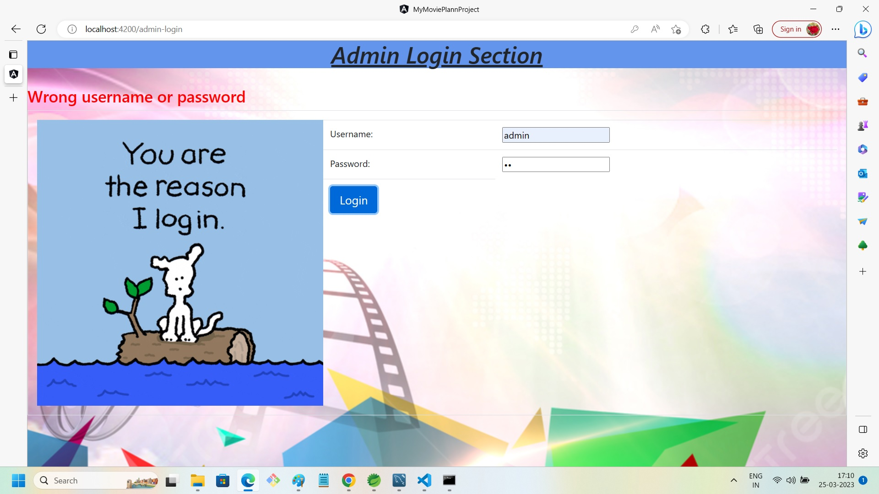

5.Admin Page After Entering Valid Credentials:

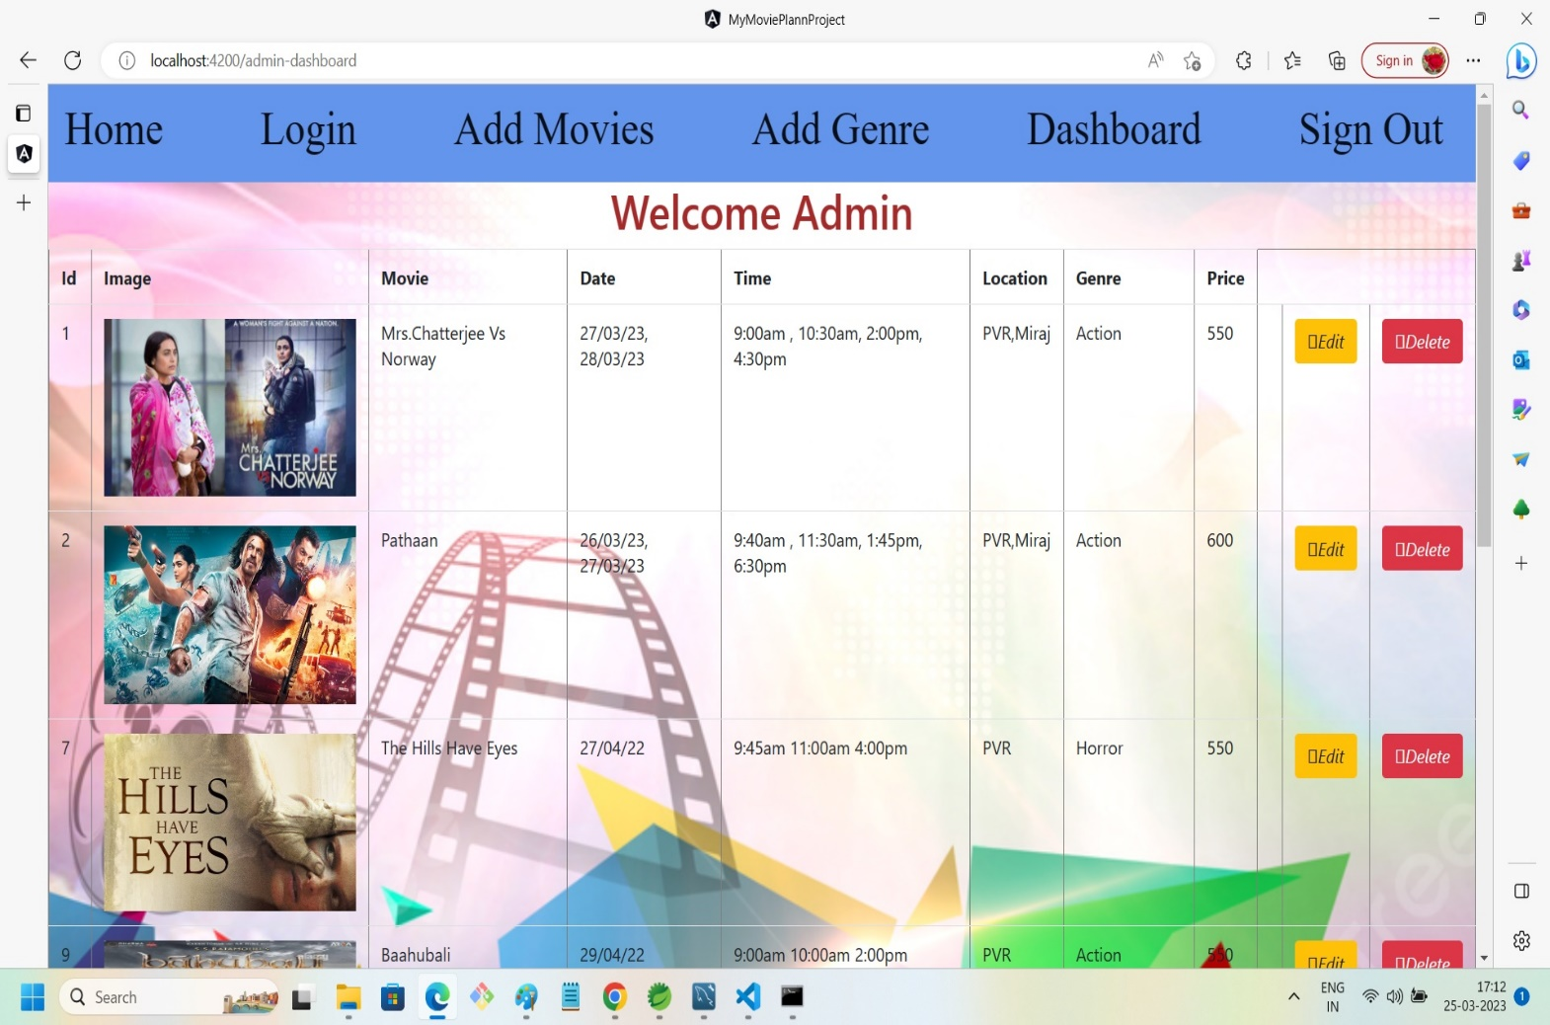

6.Admin Add Movie Ticket Section:

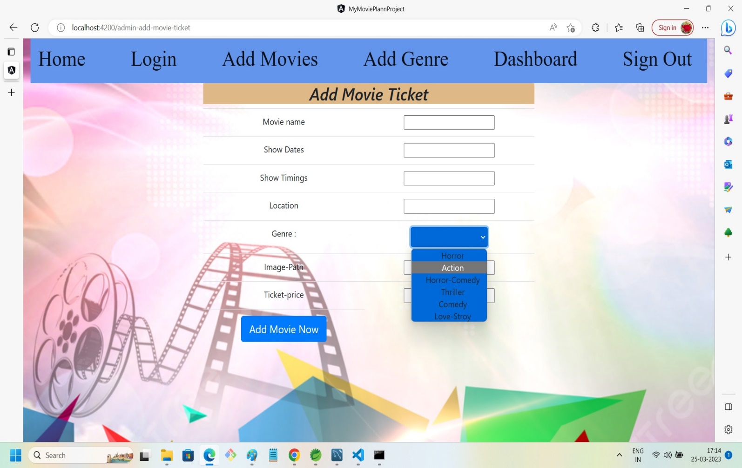

7.Admin Can Add A New Genre:

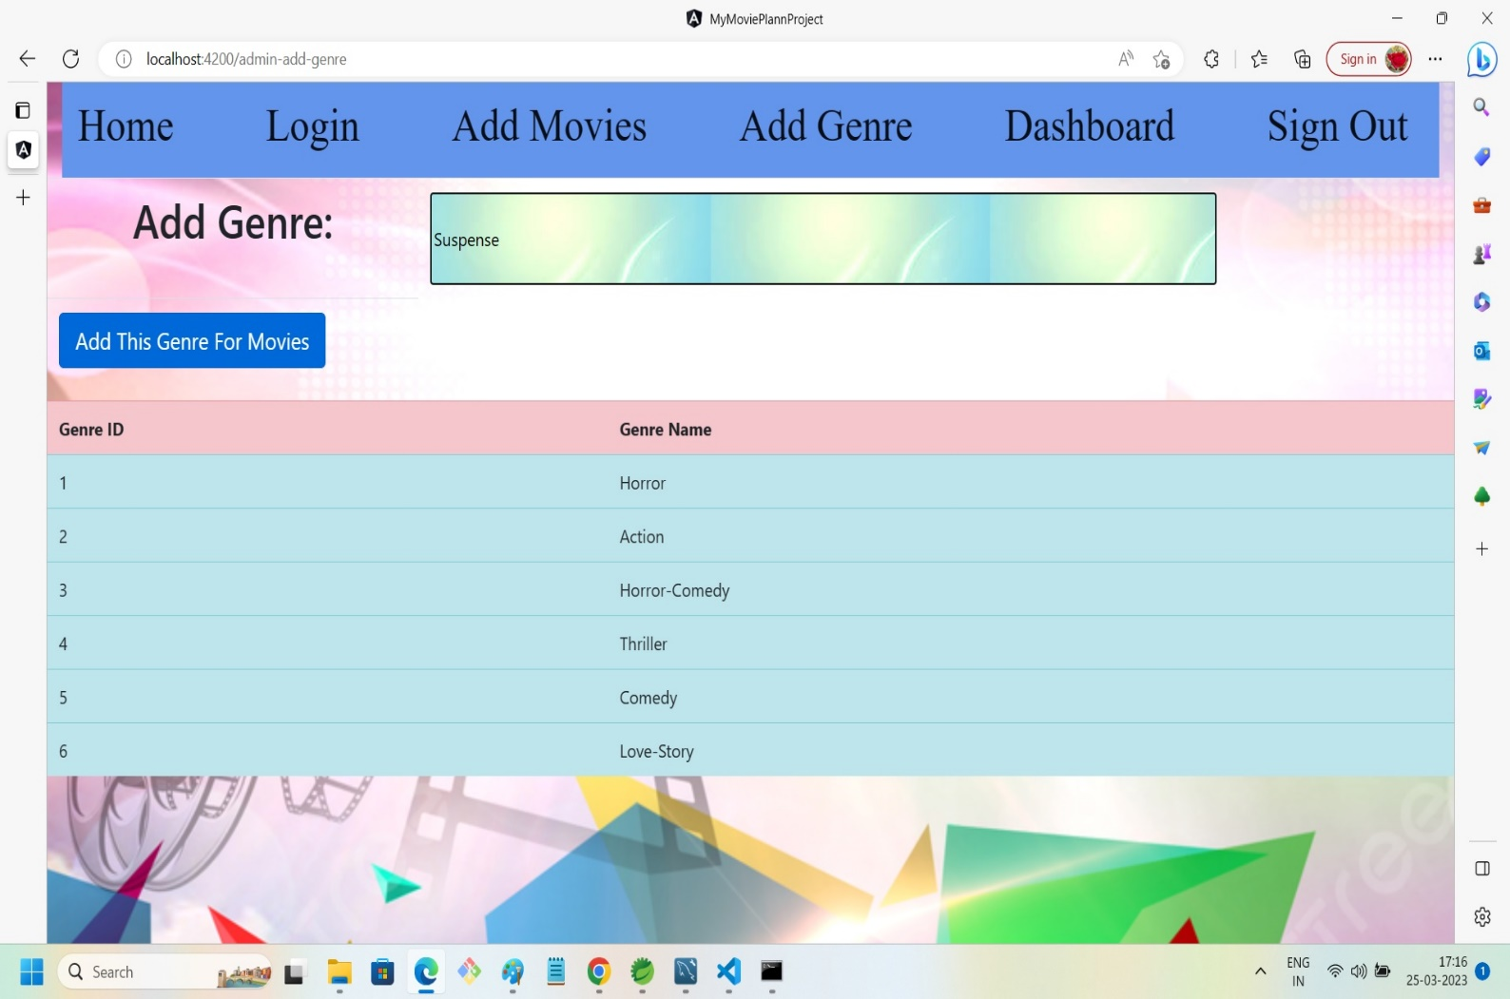

8.Admin Sign-out:

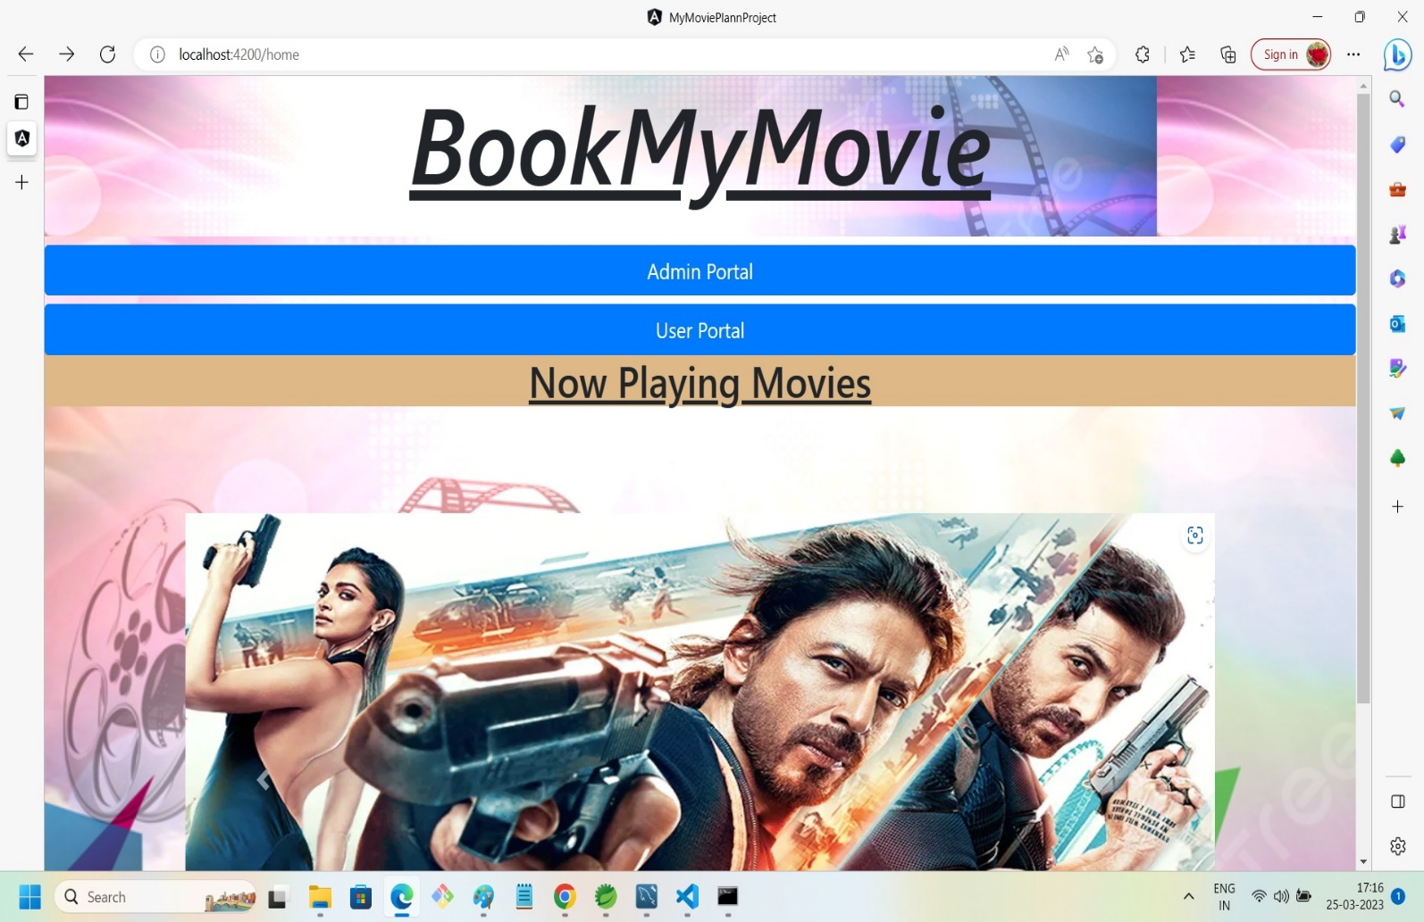

9.User-Portal:

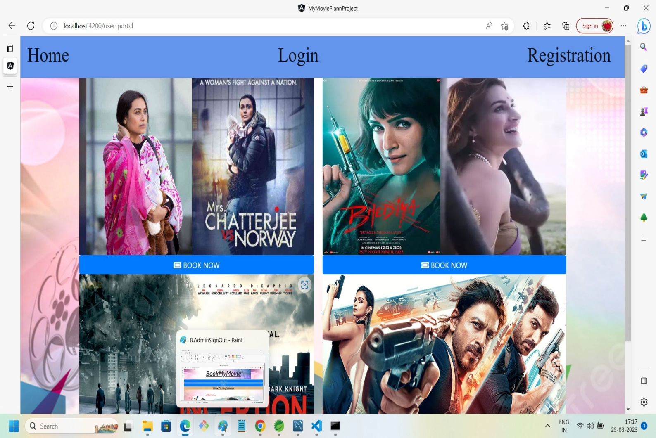

10.User-Login Section:

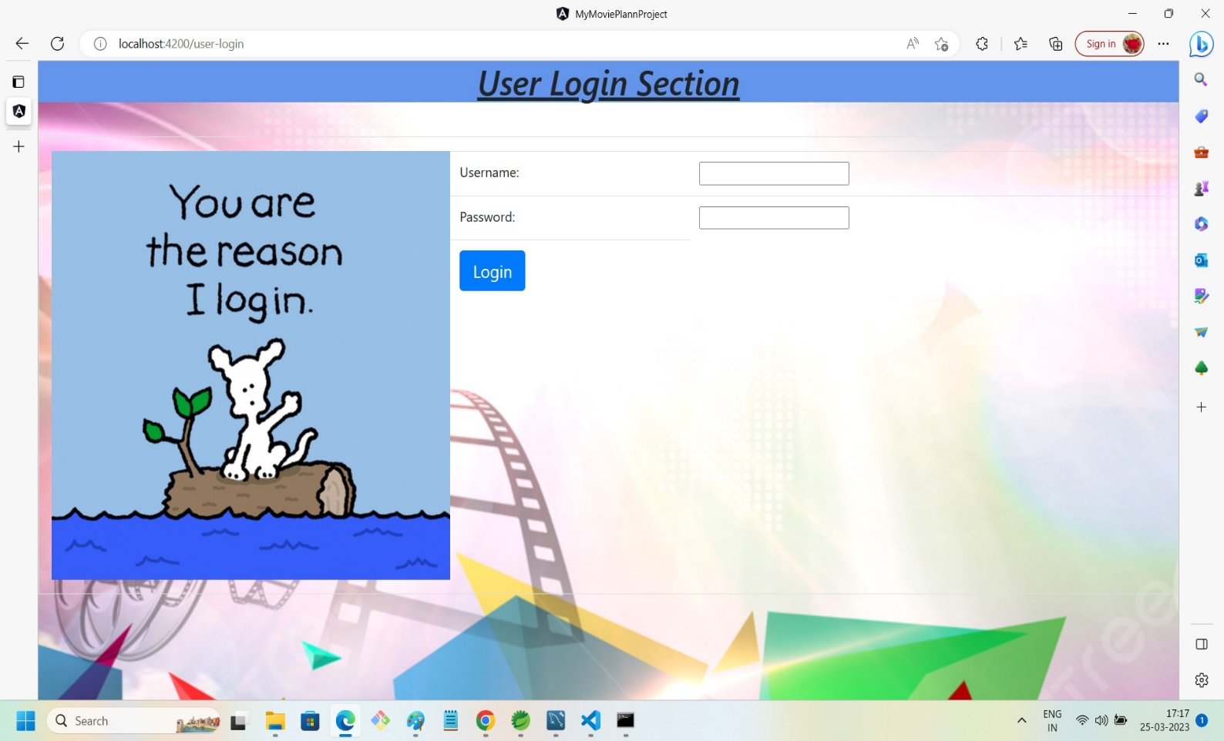

11.User Registration Section:

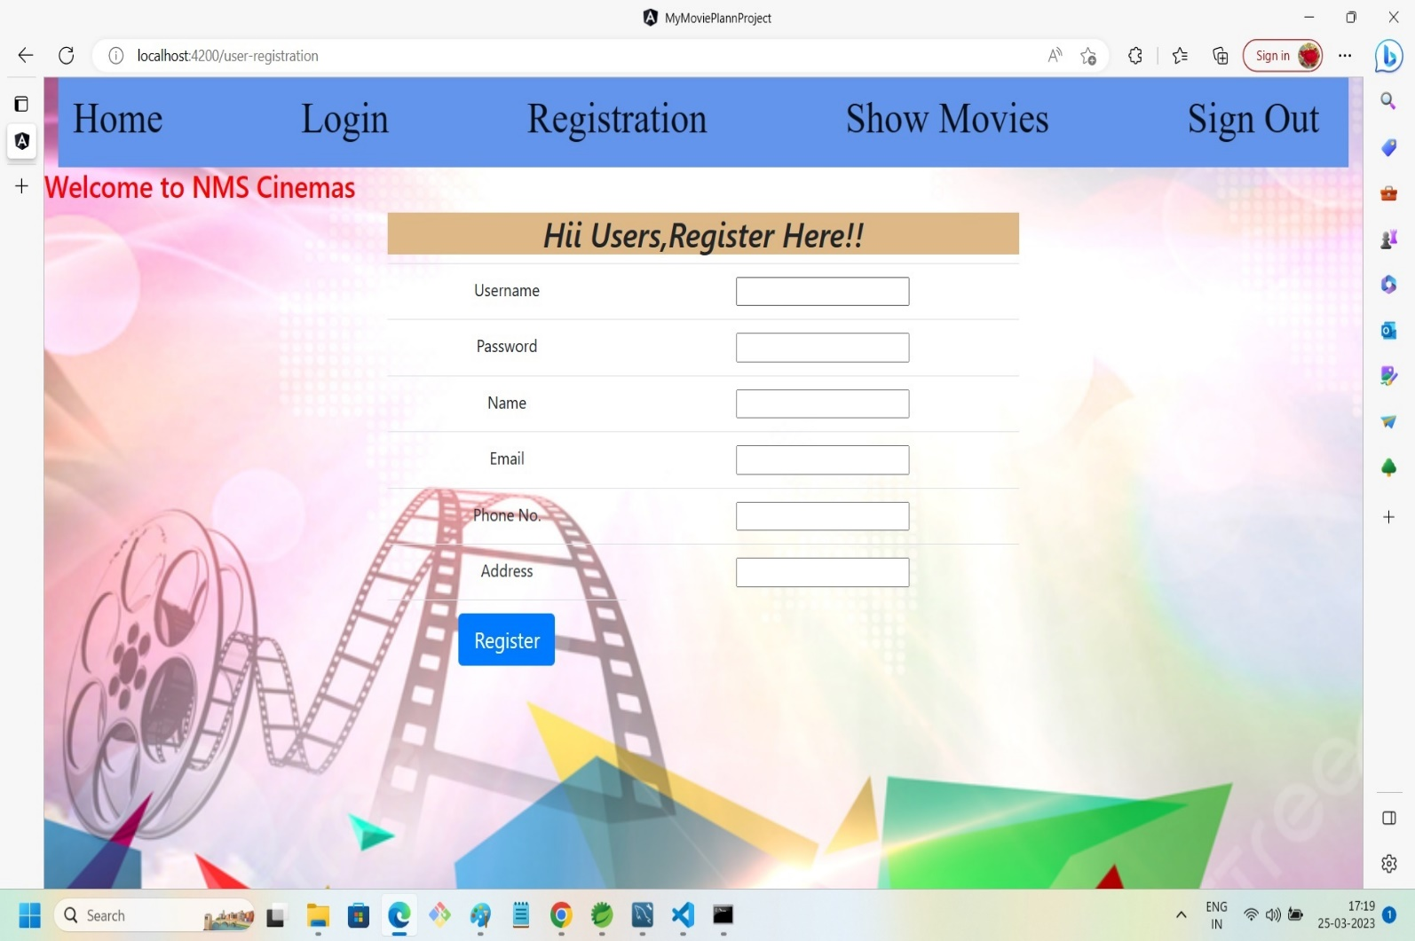

12.User Can See List Of Movies With Search/Sort By Genre Options:

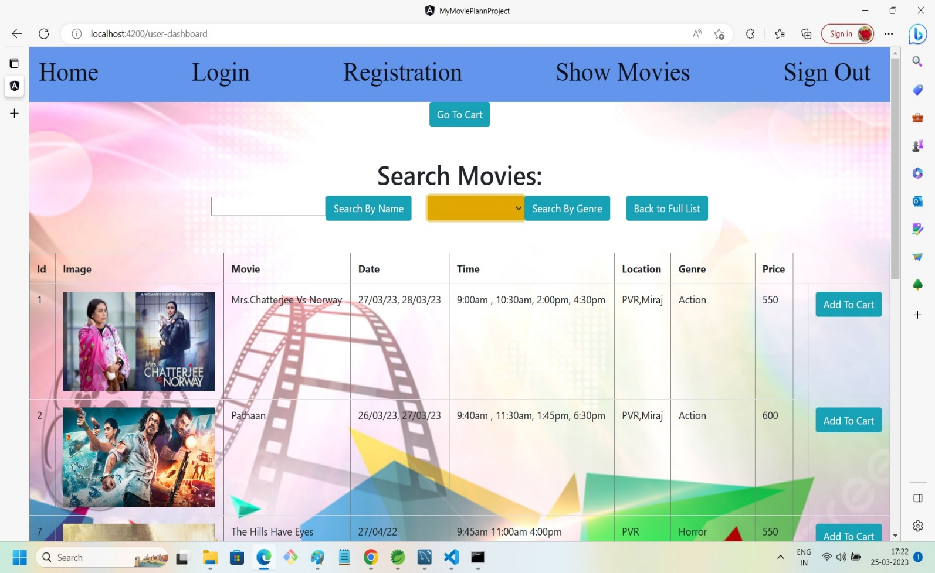

13.User Can Sort W.R.T Genre:

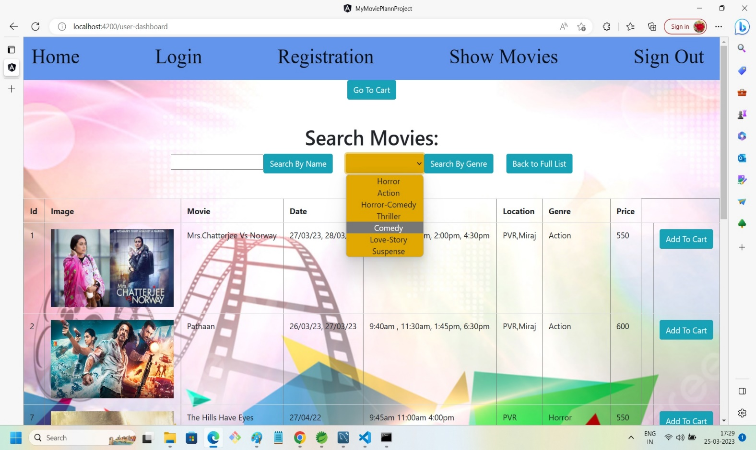

14.Sorting Result:

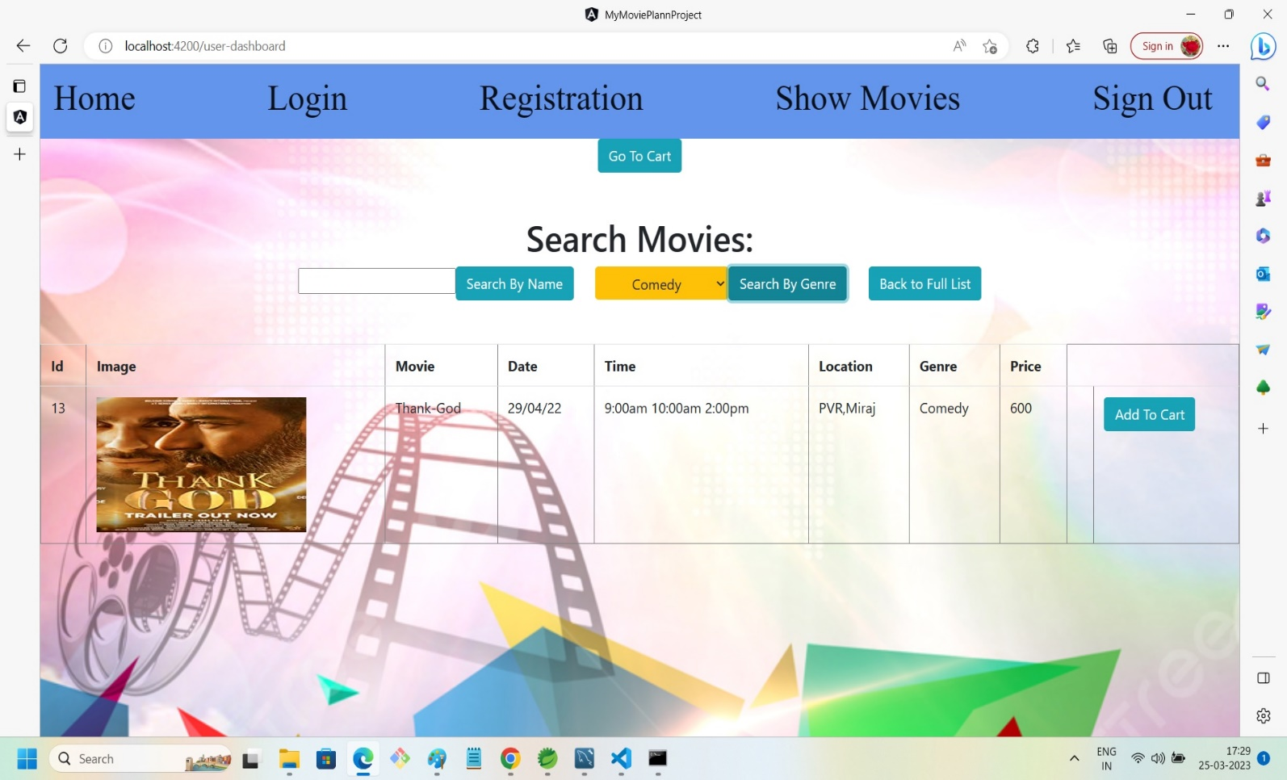

15.Confirming Purchase Details:

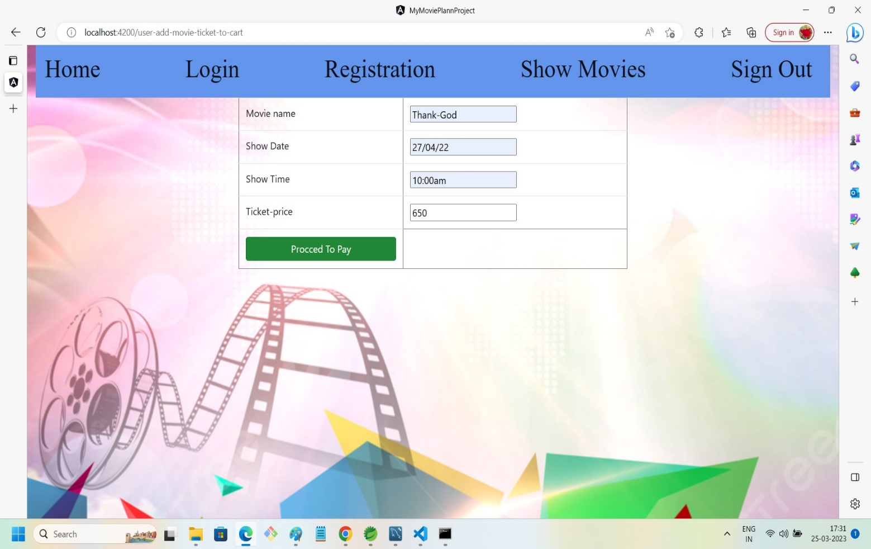

16.Payment Page:

